**SMART FARMING SYSTEM**

**BY**

**Baig Asraful Islam**

**ID: 161-15-6895**

**AND**

**Md.Yusuf Hasan Rakib**

**ID: 161-15-7482**

**AND**

**Kawser Ahmed**

**ID: 161-15-6809**

This Report Presented in Partial Fulfillment of the Requirements for the Degree of Bachelor of Science in Computer Science and Engineering

Supervised By

**MOHAMMAD JAHANGIR ALAM**

Lecturer

Department of CSE

Daffodil International University



**DAFFODIL INTERNATIONAL UNIVERSITY**

**Dhaka, Bangladesh**

**December 2019**

**APPROVAL**

This Project titled “**Smart Farming System**”, submitted by Baig Asraful Islam and Yusuf Hasan Rakib and Kawser Ahmed to the Department of Computer Science and Engineering, Daffodil International University, has been accepted as satisfactory for the partial fulfillment of the requirements for the degree of B.Sc. in Computer Science and Engineering and approved as to its style and contents. The presentation has been held on November 2, 2019.

**Board of Examiners**

**Dr. Syed Akhter Hossain Chairman**

**Professor and Head**

Department of CSE

Faculty of Science & Information Technology

Daffodil International University

**Internal Examiner**

**Designation**

Department of CSE

Faculty of Science & Information Technology

Daffodil International University

**External Examiner**

**Designation**

Department of -------

Jahangirnagar University

**DeclaratioN**

We hereby declare that, this project has been done by us under the supervision of **Mohammad Jahangir Alam, Lecturer, Department of CSE** Daffodil International University. We also declare that neither this project nor any part of this project has been submitted elsewhere for award of any degree or diploma.

**Supervised by:**

**Mohammad Jahangir Alam**

Lecturer

Department of CSE

Daffodil International University

**Submitted by:**

**Baig Asraful Islam**

ID: -161-15-6895

Department of CSE

Daffodil International University

**Md.Yusuf Hasan Rakib**

ID: -161-15-7482

Department of CSE

Daffodil International University

**Kawser Ahmed**

ID: -161-15-6809

Department of CSE

Daffodil International University

**ACKNOWLEDGEMENT**

First, we express our heartiest thanks and gratefulness to Almighty ALLAH for His divine blessing makes us possible to complete the final year project successfully.

We are grateful and wish our profound indebtedness to **Mr. Mohammad Jahangir Alam**, Lecturer, Department of CSE, Daffodil International University. Deep Knowledge & keen interest of our supervisor in the field of IoT to carry out this project. His endless patience, scholarly guidance, continual encouragement, constant and energetic supervision, constructive criticism, valuable advice, reading many inferior drafts and correcting them at all stages have made it possible to complete this project.

We would like to express our heartiest gratitude to **Professor Dr. Syed Akhter Hossain**, Head, Department of Computer Science and Engineering, for his kind help to finish our project and to other faculty members and the staff of the Computer Science and Engineering department of Daffodil International University.

We would like to thank our entire course mate at Daffodil International University, who took part in this discussion while completing the course work.

Finally, we must acknowledge with due respect the constant support and patience of our parents.

**ABSTRACT**

We live in a world that is moving rapidly towards smart systems to make every aspect of life simpler and more flexible. Today's farmers around the world are adopting many smart systems. A smart system is needed to manage and control a field and farm remotely. This system will create intelligent monitoring policies and an automated irrigation system structure for an agriculture ecosystem facility based on IoT (internet of things). This system can be designed cost-effectively by using microcontrollers, soil moisture sensors, temperature sensors, humidity sensors, LDR sensors along with the smart phone through the internet. The system will help to monitor the condition of the farm and send an action command to the farm machinery. It is an efficient mixture of numerous innovations including a shrewd sensor network structure with an android application. Besides that, a community will be created to connect all the farmers. They can communicate with other farmers for the necessary information. and a smart fertilize calculation system will be helpful for farmers to deal effectively with such demands and maximizing yields using minimum resources. Also they can find crops disses and give treatment in a proper way. Also they can knowledge to weather before irrigation and seeding. In this paper, we have created an IoT, Machine Learning and Developing based smart farming system with the features explained above.

# TABLE OF CONTENTS

|  |  |
| --- | --- |
| **CONTENS** | **PAGE NO** |
| Board of examiners | ii |
| Declaration | iii |
| Acknowledgements | iv |
| Abstract | v |

|  |  |
| --- | --- |
| **CHAPTER** | **PAGE** |
| **Chapter 1: Introduction** | **01 - 04** |
| 1.1 Introduction | 01 |
| 1.2 Motivation | 02 |
| 1.3 Objectives | 03 |
| 1.4 Expected Outcome | 03 |
| 1.5 Report Layout | 04 |
| **Chapter 2: Background** | **05 - 07** |
| 2.1 Introduction | 05 |
| 2.2 Related Works | 06 |
| 2.3 Comparative Studies | 06 |
| 2.4 Scope of the Problem | 07 |
| 2.5 Challenges | 07 |
| **Chapter 3: Requirement Specification** | **08 - 13** |
| 3.1 Business Process Modeling | 08 |
| 3.2 Requirement Collection and Analysis | 09 |
| 3.2.1 Functional Requirements | 09 |
| 3.2.2 Non-Functional Requirements | 09 |
| 3.3 Use Case Modeling and Description | 10-11 |
| 3.4 Class Diagram | 12 |
| 3.5 Design Requirements | 13 |
| **Chapter 4: Design Specification** | **14 - 20** |
| 4.1 Front-end Design | 14-18 |
| 4.2 Back-end Design | 19 |
| 4.3 Interaction Design and UX | 20 |
| 4.4 Implementation Requirements | 20 |
| **Chapter 5: Implementation and Testing** | **21 - 25** |
| 5.1 Implementation of Database | 21 |
| 5.2 Implementation of Front-end Design | 22 |
| 5.3 Implementation of Interactions | 23 |
| 5.4 Testing Implementation | 23-25 |
| 5.5 Test Results and Reports |  |
| **Chapter 6: Conclusion and Future Scope** | **26 - 27** |
| 6.1 Discussion and Conclusion | 26 |
| 6.2 Scope for Further Developments | 26 |
| 6.3 Limitations | 27 |
| **APPENDIX** | 28 |
| **REFERENCES** | 29 |

|  |  |
| --- | --- |
| **LIST OF FIGURES** |  |
| **FIGURES** | **PAGE NO** |
| Figure:1.1: Business process model for field data | 08 |
| Figure:1.2: Use Case Diagram for smart farming application | 10 |
| Figure.1.3: UML class diagram | 13 |
| Figure 2.1: Home Page (Features) | 14 |
| Figure 2.2: weather information | 15 |
| Figure 2.3: Fertilizer Calculation | 15 |
| Figure 2.4: Fertilizer Calculation result | 16 |
| Figure 2.5: Agro Help Center | 16 |
| Figure 2.6: Agro Community(post) | 17 |
| Figure 2.6.1: Agro Community(comment) | 17 |
| Figure 2.7: Agro Information | 18 |
| Figure.2.8 Field data and controlling switch | 18 |
| Figure:3.1: Data base for Login | 19 |
| Figure:3.2: Data base for Registration | 19 |
| Figure.4.1 Registration Page | 21 |
| Figure.4.2 Login Page | 22 |

**LIST OF TABLES**

|  |  |
| --- | --- |
| **TABLES** | **PAGE NO** |
| Table 1: Name of some tests | 23 |
| Table 2: Functional Testing and Result | 24 |
| Table 3: Android UI Testing and report | 24 |
| Table 4: Network Testing and report | 25 |

**CHAPTER 1**

**INTRODUCTION**

**1.1. Introduction**

Cultivating is a significant input division for the financial improvement of any nation. Like Bangladesh, most of the populace is reliant on agriculture. But our country is not fully digitalized. Our farmer they are working very hard to grow crops and the system of growing crops is manual. Our neighbor country India is using many features of advanced technologies that help their farmers to get a secured farming environment. So we should bring new technology to our farming sector and introduce those helpful technologies to our farmers.

Smart Farming is a cultivating management idea using modern technology to improve the quality of agricultural items [1]. Smart Farming providing plants diagnosis and proper treatment. Smart Farming make a agro community and it’s providing many other thing likes weather view, soil fertilizer suggestion, agro information, help center, smart farming web. It’s simply the use of technology to collect data from the field using sensors and make intelligent decisions to help the farmer. A smart cultivation model is a real-time monitoring system. It monitors the soil characteristics like temperature, humidity soil moisture, PH, etc. It is conceivable to manage various tasks of the field remotely from anyplace, whenever by IoT. It allows a cutting edge lifestyle where an individual gets the opportunity to control his electronic gadgets utilizing a cell phone it additionally offers proficient utilization of vitality [2].

**1.2. Motivation**

Nowadays our population is increasing and various natural disasters are occurring. And because of this our agricultural land is declining. Farmers are experiencing pressure to deliver more quality food and utilize less vitality and water in the process. It is seen that farmers constantly face irrigation managing issues, land overseeing issues, climate impacts [5]. We understand cultivation is based on managing recourse and obtaining harvest. So farmers should be interested in modern technologies where they can optimize recourse usage precisely.

We are also inspired by a TV program named "Mati O Manush". Through this program, the farmers of Bangladesh got many benefits. From then we wanted to help our farmers with our skills and expertise. With the flow of that inspiration, we created this system to reduce the problem of the farmers. The main purposes are down below.

* To reduce farming cost
* To save time of farmers
* For environment monitoring and assessment
* For 24 hours field monitoring
* To get instant treatment information for affected crops or animals.
* To increase and motivate the young farmers.

**1.3. Objectives**

IoT, Machine learning and Developing based smart cultivating frameworks can demonstrate to be useful for farmers since over just as less irrigation isn't useful for cultivating. Edge esteems for climatic conditions like humidity, temperature, moisture can be fixed depending on the ecological states of that specific area. This system give agro community, plants diagnosis and treatment, agro farming proper knowledge. This system gives automated irrigation and produces the required resources for cultivating dependent on the sensed continuous information from the field [2]. We proposed a system using IoT. It will help the farmer to control the water usage while monitoring the required water level and avoid water shortages using moisture level detecting sensors already installed in the field and the application will notify farmers about the most current conditions and details of their field. To save the electricity we create an automated (fan & light) on/off the system using temperature and LDR sensor. So using IoT our farmer can overcome most of the problems they face.

**1.4. Expected Outcome**

Our farmers are mostly living in remote areas where problem-solving is often a matter of time when they need to wait for the actual agriculturist. They spend most of the time farming. At the time, they don't know about the new technology [4].

Our IoT based system helps a farmer to maintain his field and animal farm properly. To avoid water shortage we use moisture level distinguishing sensors that previously introduced in the field. Based on soil moisture reading a pump will be turned automatically on or off. Our intelligent calculation system will generate a necessary resource list for cultivating crops. And our mobile application provides a list of diseases and treatments about farming animals and crops.

**1.5 Report Layout**

**Chapter 1: Introduction**

In this section, we have talked about the presentation, inspiration, goals and the normal result of the undertaking.

**Chapter 2: Background**

We study the foundation conditions of our project. We additionally talk about the related works, correlation with other competitor frameworks, the extent of the issue and difficulties of the project.

**Chapter 3: Requirement Specification**

This section is about necessities like business process demonstrating, the prerequisite assortment and investigation, the utilization case model of the venture and their portrayal, the legitimate information model and the structure prerequisites.

**Chapter 4: Design Specification**

In this part, every structure of the project like front-end configuration, back-end plan, association structure, and UX is given. The execution prerequisites are additionally talked about.

**Chapter 5: Implementation and Testing**

This section contains the execution of the database, front-end plans, co-operations, test usage and the test consequences of the venture.

**Chapter 6: Conclusion and Future Scope**

We addressed the conclusion and the potential for further improvements that stem pretty much from the project.

**CHAPTER 2**

**BACKGROUND**

**2.1 Introduction**

Our main motivation behind “Smart Farming” was to develop a little scale model pilot structure to demonstrate the key features of the great developing use case. Farmers in our country are not aware of the technological growth that happened in developing countries. They also need to have the opportunity to cultivate their crops in a better way that reduces the chance of loss on their profit.

This project will be a very reliable environment for a farmer. It’s an IoT and mobile application based project. We use some rest api and cloud ml kit. We use arduino uno r3 and sensors to make this project and also use android and firebase database for a framework [3]. Farmer’s will like to use this project for their benefit. To develop Bangladesh’s economic condition and give the farmer a step ahead we have created a digital farming system with all advantages and facilities. In this system, all facilities are available for helping farmers. Here will be available many experts location and contract number to solve farmer’s problem. They will give a proper solution to the farmer which will be very helpful for farmers. A farmer can know his crop information at any time without the internet. A farmer can know weather information at any time. A farmer diagnosis his crops disses and give treatment in a proper way. A farmer can also visit some necessary government websites through our mobile application. This service is available for 24 hours.

**2.2 Related Works**

Each year millions of farmers suffer many kinds of difficulty like a flood, drought, fertilizer, Insects, lack of pure and resolute seeds, etc [6]. It is not possible to fully overcome them to use our IoT based project. But Smart farming is a more useful and informative system where it will help the farmer to overcome such kind of difficulty.

There is no such work as the same as this work in our country. As of late, our administration attempts to give farming help like us. There are some works as a smart environment monitoring system and smart farming websites that contain only information. But our IoT and android application based system work automatically to help the farmer by monitoring their field and give necessary live information.

**2.3 Comparative Studies**

There are many websites or applications to provide service for a farmer in online. But the websites provide traditional horticultural data and some of giving market data [7].

But we’re trying to do something new that will help the farmer in Bangladesh about automation, climate change, detect diseases of their respective crops and many challenges that they face in their farming. Our system provides the location and contact number of the nearest officer who works for the betterment of agriculture.

**2.4 Scope of the Problem**

Our project is for the farmers and those who want to make roof gardening and those who want to make a domestic animal farm. They can know a new method of irrigation. This will reduce the extra cost of workers and necessary materials for cultivating. Although the whole process like automatic motor ON/OFF, setup the system and the implementation of the application may be a fact to a non-professional user who does not have any knowledge of this type of system.

That is why we are building our application in the "Bangla" language and developing the system as simple and friendly as possible.

**2.5 Challenges**

Bangladesh still being a developing country and farmers mostly being unaware of new technologies still use traditional means of farming which are now ineffective and inefficient.

So the main challenge is to introduce our system to the farmers and help them to learn how to use the system. Another challenge is to make the system as simple as possible for everyone.

**CHAPTER 3**

**REQUIREMENT SPECIFICATION**

**3.1 Business Process Modeling**

A business procedure is the planning of legitimately connected responsibilities to complete a fixed business result. Business procedures are usually classified as essential and supporting business forms. It is significant in light of the fact that it shows how the necessities have connected with the framework application. It centers on the business forms that are occurring and how these prerequisites can be accomplished all the more effectively to complete the undertaking.

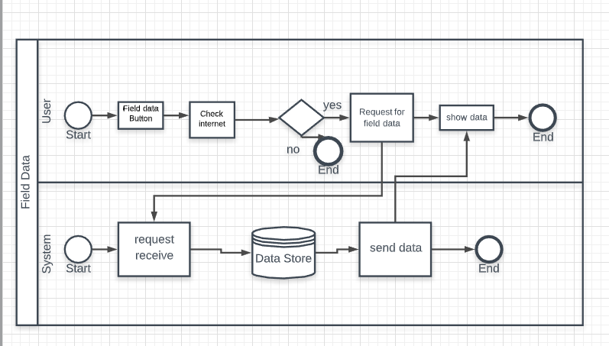

Figure: 1.1: Business process model for field data

**3.2 Requirement Collection and Analysis**

Requirement analysis and collection are most essential requirements for any development process. We have gathered fundamental necessities from the field level and the web. We also did a survey to analyze the needs and requirements of farmers. We collect data from government agriculture university and government agriculture office.

**3.2.1 Functional Requirements:**

* Farmer Registration
* Farmer Login
* Farmer Dashboard
* Request for crops information
* Request for animal information
* Forum that calculate fertilizer for cultivation
* Request for the nearest government agriculture officer’s location and contact number.
* Live weather (temperature and humidity)

**3.2.2 Non-functional Requirement**

Non-functional requirements are additionally significant because it enhances execution, memory expending and load as speedy as could reasonably be expected.

* The system is easy to use and navigate
* System user interface should be user-friendly

**3.3 Use Case Modeling and Description**

In our design, two actors play their roles. The system and the farmer are these two actors. A farmer must be registered to log in to the application. At this time the system will verify the validity of the information provided by the farmer. Then the farmer can do his required work which provides the application.

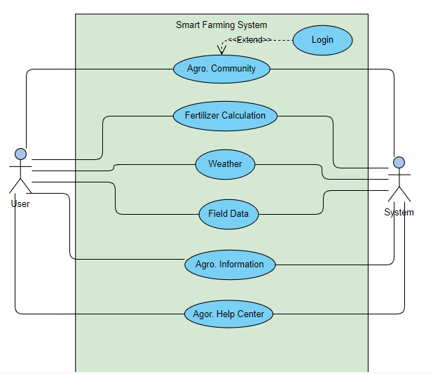

Figure: 1.2: Use Case Diagram for smart farming application

**Use case explanation for Login:**

|  |  |
| --- | --- |
| ID: 01 |  |
| Use case: Login |  |
| Pre-Condition: Registration |  |
| Actor: Regular user |  |
| Main Flows / Primary Path: | 1. Select Agro. Community |
|  | 2. Enter user mail |
|  | 3. Enter password |
|  | 4. Click Login button |
|  |  |
| Secondary Path: | 2.1. Incorrect mail |
|  | 3.1. Incorrect password |
|  | 4.1. Internet error |
|  |  |
| Note: | Baig Asraful Islam |

**Use case explanation for Registration:**

|  |  |
| --- | --- |
| ID: 2 |  |
| Use case: Registration |  |
| Pre-condition: First time use |  |
| Actor: Regular user |  |
| Main Flows / Primary Path: | 1. Select agro. community |
|  | 2. Enter name |
|  | 3. Enter mail |
|  | 4. Add profile image |
|  | 5. Enter password |
|  | 6. Confirm password |
|  | 7. Click registration button |
|  |  |
| Secondary Path: | 3.1. Invalid mail |
|  | 3.2. Mail already exist |
|  | 6.1. Password is not same |
|  | 7.1. Requirement incomplete |
|  | 7.2. Internet Error |
|  |  |
| Note: | Baig Asraful Islam |

**3.4 Class Diagram**

The Class diagram for the application consists of the interfaces, methods, variables, and relationships between them.

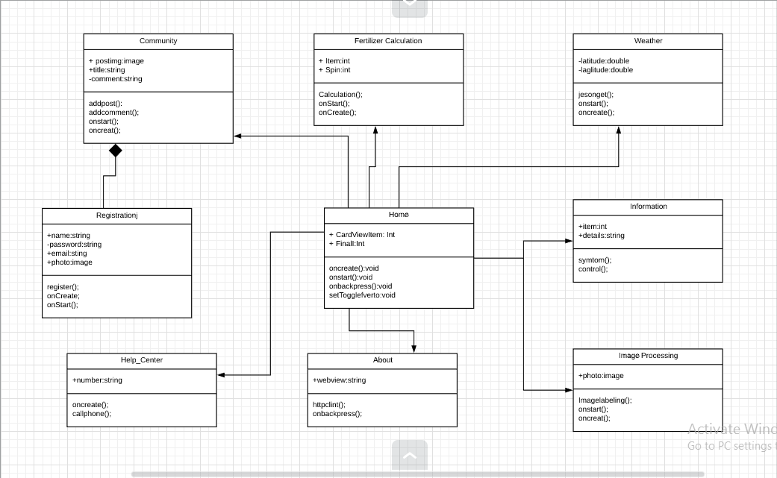

Figure.1.3: UML class diagram

**3.5 Design Requirement**

Design requirements are a very important part of an application that makes the application unique from any other existing application. In our application, we focused on farming facilities and the farmer's needs. We work with some special feature and this requirement will be very helpful for user who wants to use our application. We have designed our application by the following features.

* In our application, we have two types of users. One is normal user like farmer and the other one is admin.
* Admin can control everything in the application. A system administrator will arrange the fundamental settings of the framework.
* User has to create account to store his data and log in to use features.
* Clients will give some data like name, telephone name, and so on.
* To use some unique features user have to allow his internet

To see “Field and Farm” instant information user has to install some required sensor in his field and farm.

**CHAPTER 4**

**DESIGN SPECIFICATION**

Design Specification is an explanation of how to develop a design. In the Design Specification chapter, we attempt to demonstrate the application's front-end and back-end design. Some instruments and platforms are also available that we used to create this application.

**4.1 Front-end Design**

Front-end is the most important part of developing an application. It works at the introduction layer and clients can connect with it straightforwardly. It is essential to build up a straightforward and effectively understanding front-end for the clients. So we attempted to keep our UI as straightforward as could reasonably be expected and effectively available for the client.

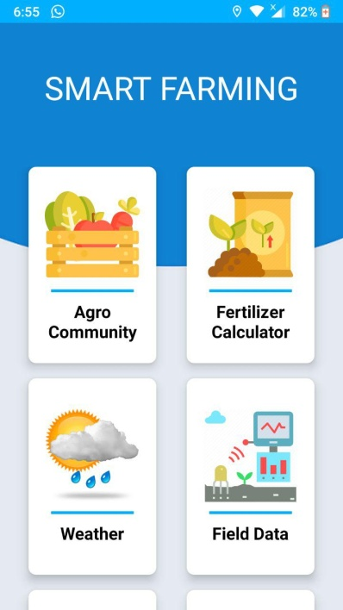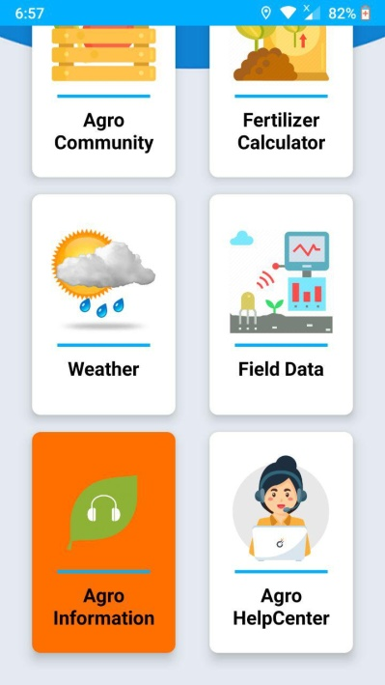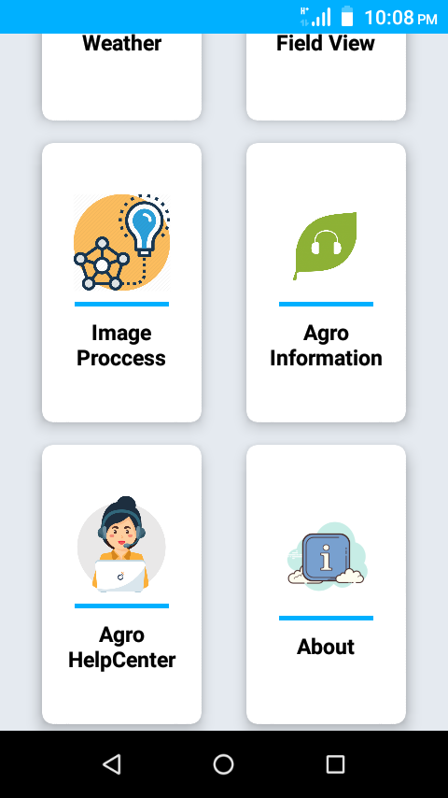

Fig.2.1: Home Page (Features)

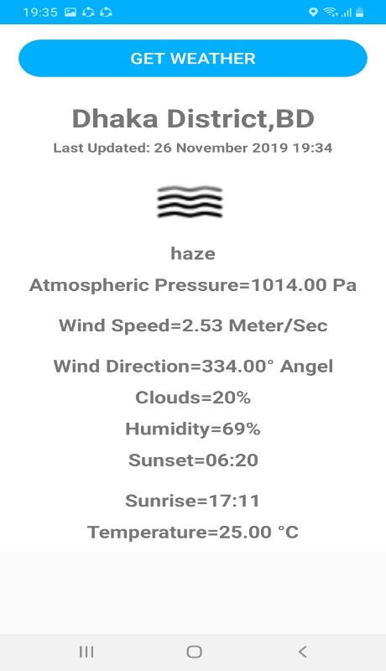

Fig.2.2 weather information

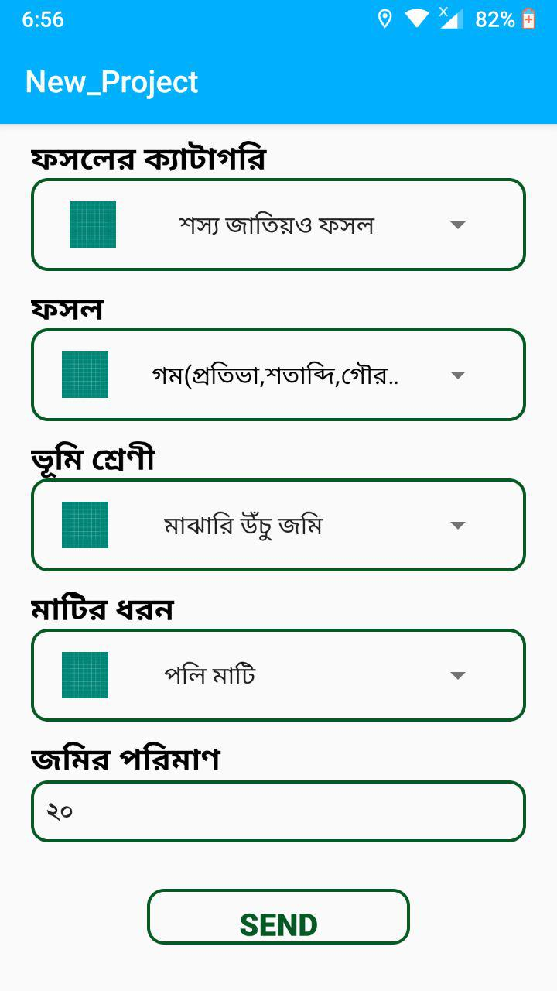

Fig.2.3 Fertilizer Calculation

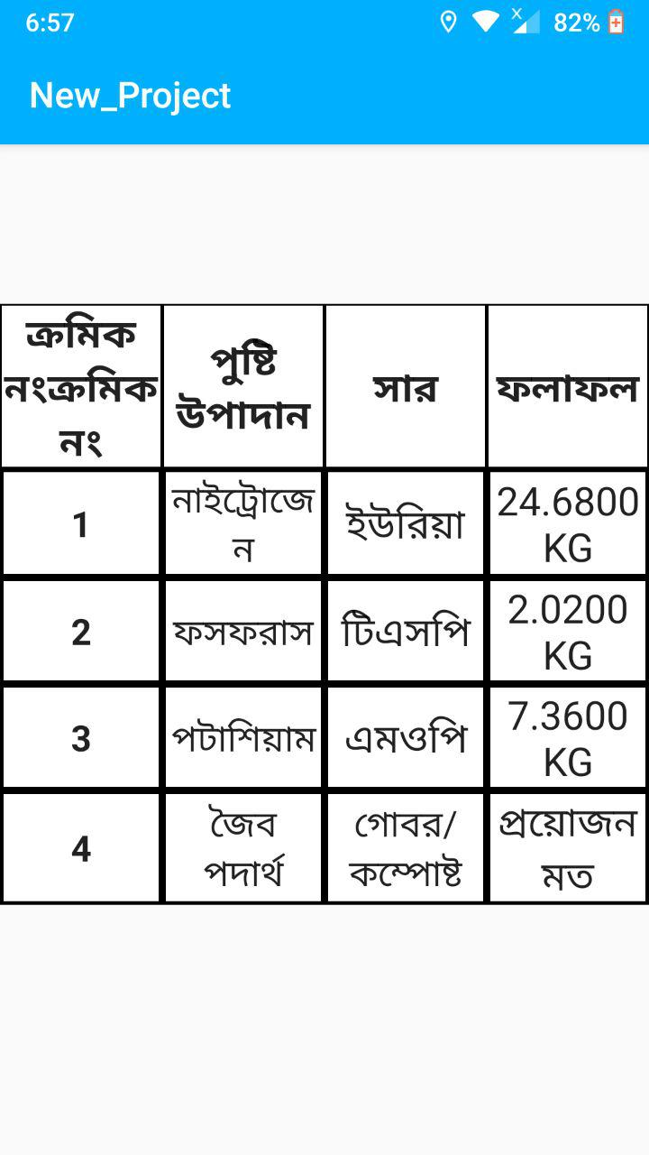

Fig.2.4 Fertilizer Calculation result

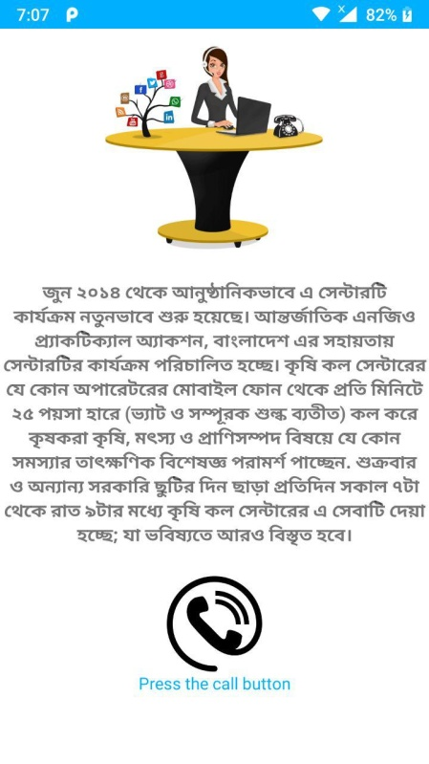

Fig.2.5 Agro Help Center

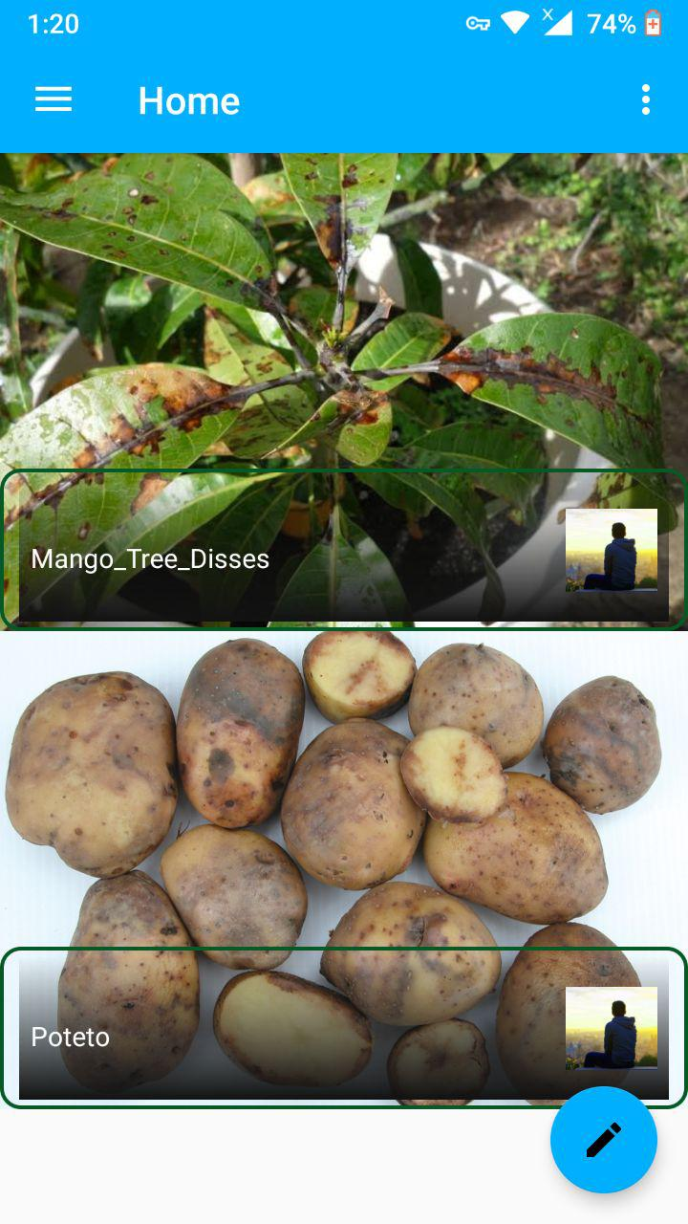

Fig.2.6 Agro Community (post view)

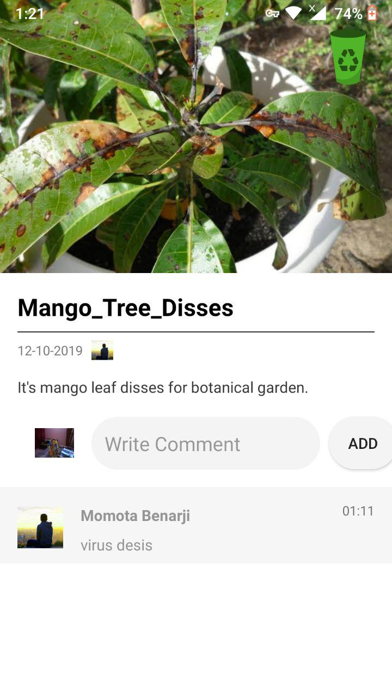

Fig.2.6.1 Agro Community (comment option)

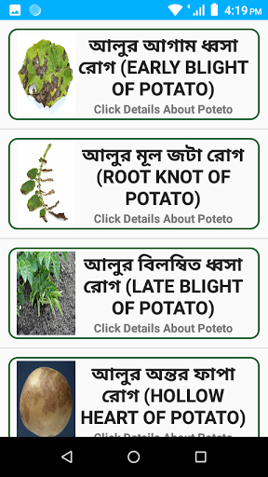

Fig.2.7 Agro Information

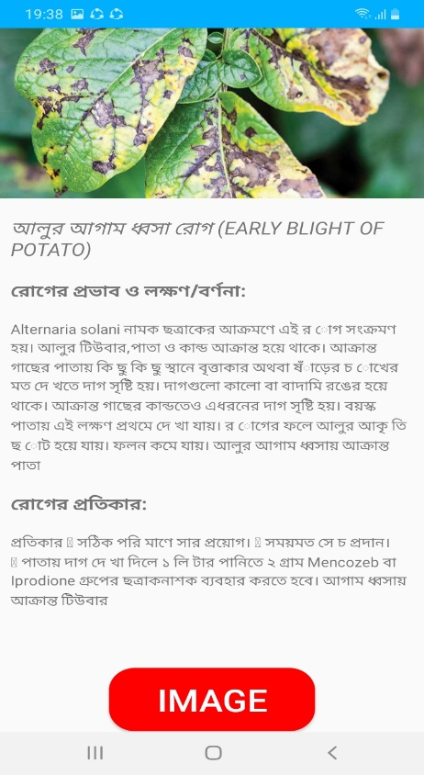

Fig.2.8 Plant’s Diagnosis and treatment

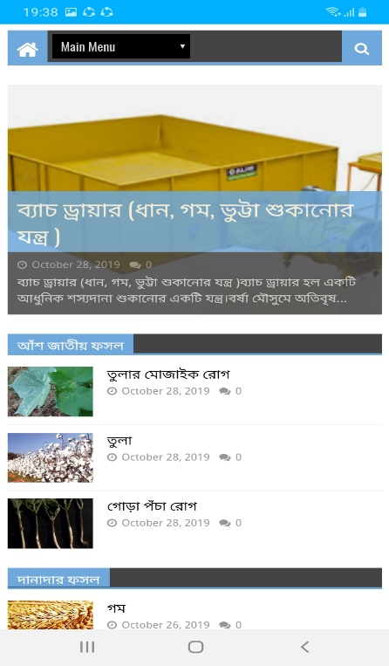

Fig.2.9 Smart Farming website.

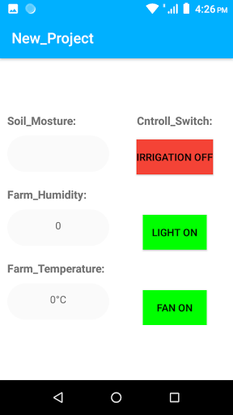

Fig.3.0 Field data and controlling switch

**4.2 Back-end Design**

The Back-end design is the part which works behind a project. A clint can’t view or notify the back-end part. Users only use the front-in interface to communicate with the application. A client doesn't need to understand how this part is working. The back-end does almost everything that happens on the application. To handle the back-end part is very complex because back-end normally consists of programming languages as here Java, C are used.

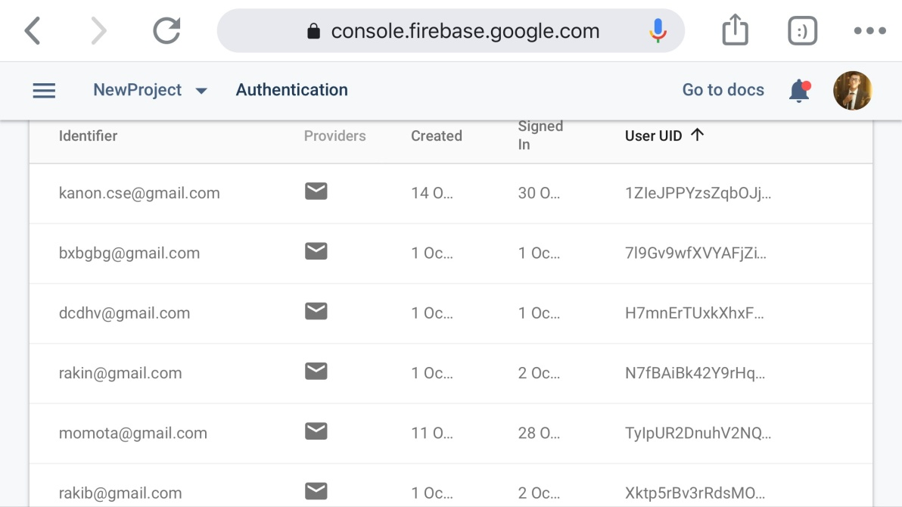

Figure:3.1: Data base for Login

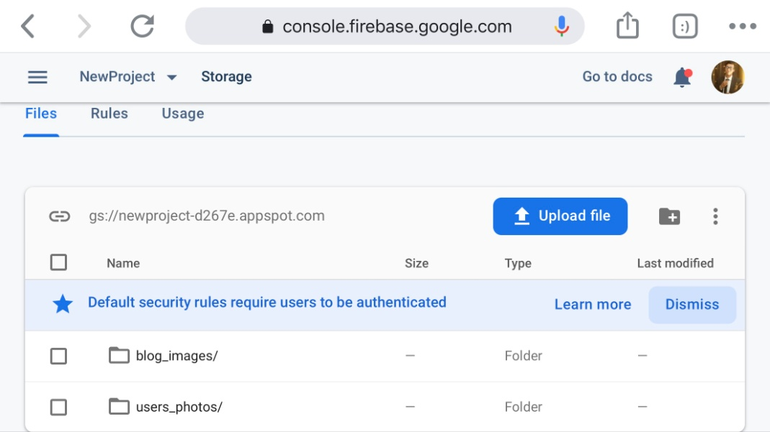

Figure:3.2: Data base for Registration

**4.3 Interaction Design and UX**

Interaction design describes the communication between the user and the application. Interaction design considers how the user provides space, processes problems, and discovers results. It performs related activities and takes care of problems in performance.

The interaction design of an application essentially centers on the general experiences between the users and the application. In our application, all the features interact with the user. We are primarily focused on the applicability of the application and there is an option where the user will need to register and log in to the application using their verified information.

In our application for UX, we have tried to give our users a great experience by adding some new features. We attempt to keep our application straightforward and simple to use for better execution and experience for the client.

**4.4 Implementation Requirements**

To develop this project, we used various types of devices, parts, and programs [8]. For implementation requirements, we categorized our project into two-part.

**Our application's front-end and back-end design as follows:**

* Java is used to create android application.
* Rest api used.
* Weather api used.
* Machine Learning using for image proccessing
* C language is used for arduino programming.

**Hardware Components**

* Temperature sensor [9]
* Humidity sensor [9]
* moisture sensor
* Micro controller board (Arduino uno R3) [3]
* Wifi module (Nodemcu-ESP8266)
* Power supply
* Mini Water pump
* DC Motor

**CHAPTER 5**

**IMPLEMENTATION AND TESTING**

**5.1 Implementation of Database**

Here, we have focused on how we implement our database. As we mentioned earlier for our project we use the Firebase database [10]. All the data will be stored in our database along with farmer's information.

**5.2 Implementation of Front-end Design**

An application can attract users with its design that is easily understandable and user-friendly. Our android based application work some features without the internet and some feature requires the internet. So, we try our best to keep our design understandable also user-friendly. We've used a very simple UI design, so if a user opens a feature of our app, just by looking at the screen, they'll understand what this feature does.

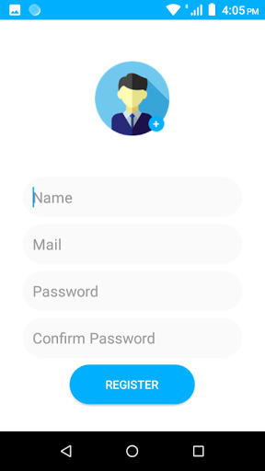

Figure.4.1 Registration Page

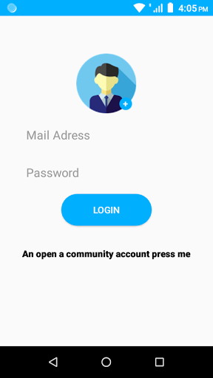

Figure.4.2 Login Page

**5.3 Implementation of Interactions**

The success of a system completely depends on the interaction with the user. Interaction is what makes a system popular and attractive to a user. So, making a process interactive is very important. We develop some unique features to interact with our users.

We have implemented our system with 'Bangla' font for easy and better user experience. The system is user-friendly and a user can easily interact with our system. Our application has been successfully implemented and has impressive interaction with users.

**5.4 Testing Implementation**

Implementation testing usually refers to the process of testing the implementation of technical specifications. This process serves the dual purpose of verifying that the specification is, in fact, applicable and the implementation fits the specification. This process helps in the implementation of quality and development of interoperability.

Table 1: Name of some tests

|  |  |
| --- | --- |
| **No.** | **Test name** |
| 1. | Functional Testing |
| 2. | Android UI Testing/Interface Testing |
| 3. | Compatibility Testing |
| 4. | Network Testing |
| 5. | Security Testing |

**5.5 Test Results and Reports**

The test report formally presents the test results. The report contains information that we have assessed in an expert and sorted out way. The report describes the operating condition and shows the test results with the purpose of the test.

A test report is very important to know that the system is ready or not to be implemented. Data obtained from evaluation tests are recorded by this document.

Here are some test results:

Table 2: Functional Testing and Result

|  |  |  |  |  |  |
| --- | --- | --- | --- | --- | --- |
| **Step**  **No.** | **Test case** | **Test data** | **Expected**  **result** | **Actual**  **result** | **State** |
| 1. | Verify whether the required mandatory fields are working as required. | Mobile,  App,  Internet | All fields are working. | All fields are working. | pass |
| 2. | Verify whether the mandatory fields are displayed | Mobile,  App,  Internet | All fields are displayed. | All fields are displayed. | pass |
| 3. | Verify whether the application works as per as requirement whenever the application starts/stops. | Mobile,  App,  Internet | Application starts/stops  as required. | Application starts/stops  as required. | pass |

Table 3: Android UI Testing and report

|  |  |  |  |  |  |
| --- | --- | --- | --- | --- | --- |
| **Step**  **No.** | **Test case** | **Test data** | **Expected**  **result** | **Actual**  **result** | **State** |
| 1. | Verify whether the interface is easy to understand. | Mobile,  App | Easy to understand. | Easy to understand. | pass |
| 2. | Verify whether the image, buttons and information are shown properly aligned with the mobile screen size. | Mobile,  App | Shown properly. | Shown properly. | pass |

Table 4: Network Testing and report

|  |  |  |  |  |  |
| --- | --- | --- | --- | --- | --- |
| **Step**  **No.** | **Test case** | **Test data** | **Expected**  **result** | **Actual**  **result** | **State** |
| 1. | Check internet request/response to/from the service in various conditions. | Mobile,  App,  Internet | Real time  response | Response is good. | pass |
| 2. | Verify the response time in which the activity is performed like refreshing data. | Mobile,  App,  internet | Real time  response | Real time  Response. | pass |
| 3. | Check whether the app run through strong wifi connection and the mobile data network. | Mobile,  App,  internet | Real time  response | Response is good. | pass |

After all these testing, we can conclude about our app that:

* Better application quality.
* Easy to use.
* Easy and understandable UI for interaction.

**CHAPTER 6**

**CONCLUSION AND FUTURE SCOPE**

**6.1 Discussion and Conclusion**

This system is really for people who are involved in agricultural work and those who want to have a small garden on their terrace. This application has a user-friendly design. The main reason for developing this application is to help farmers and make agriculture work easier for them.

Keen horticulture utilizing IoT has been tentatively demonstrated to work skillfully by effectively checking dampness and temperature esteems. Depending on the soil moisture, an adequate amount of water will be provided by an automatic irrigation system. It also stores sensor parameters over time. This will assist the client in analyzing the conditions for various parameters of the field whenever, anyplace. Finally, through the mobile application, user can get the information he needs for cultivating a specific crop. And he can also find primary treatment information for his animal, including the information of a veterinarian.

**6.2 Scope for Further Developments**

In the future this application can be improved by adding the following functionality:

* Some necessary expensive sensors can be added to make the project more accurate and easier.(like PH sensor)
* Artificial intelligence can be added to detect and analyze the diseases of animals and crops.
* A website can be created for more and recent information on agriculture.
* A free seminar can be arranged to use this system efficiently.
* An online marketing can be add to make sell easy for farmers.

**6.3 Limitation**

There are some limitations to this project. Our main target is a farmer. Those who face many problems for their old farming processes and some unknown diseases can learn a new method of farming. Our specific limitations are as follows:

* Farmers are not familiar with this IoT based Smart farming.
* Maintaining a proper Internet connection.
* Maintaining a proper system setup.
* Firebase database is limited and it requires internet.
* It is difficult to agree with the agricultural officer for providing services.
* Managing a huge amount of data.

# APPENDIX

From the Summer-2019 semester, we had started our experience to cause a structure where a user can monitor his field and farm. Use can control the fan, light and water pump. We try our hard to make the system as flexible as possible. We use microcontrollers to reduce costs. If a user doesn't want to install the microcontroller he can use our mobile application. In our mobile application, we developed many features that can be very helpful to users. We have built up a web blog for more information. We are trying to bring image processing in our application. These features can be very helpful not only for the farmer but also for all regular users. Since our point of view is to satisfy all customers from different stages.

**REFERENCES**

1. “Definition of smart farming” [Online]. Available: <http://www.fao.org/family-farming/detail/en/c/897026/>[Retrieved on 06 August 2019].
2. “Automatic irrigation system” [Online].Available: <https://www.elprocus.com/microcontroller-based-automatic-irrigation-system/> [Retrieved on 07 August 2019].
3. “About arduino uno” [Online].Available: <https://en.wikipedia.org/wiki/Arduino_Uno> [Retrieved on 02 june2019].
4. “About digital agriculture” [Online].Available: <https://en.wikipedia.org/wiki/Digital_agriculture> [Retrieved on 08 august 2019].
5. “Smart agriculture on climate” [Online]. Available: <https://en.wikipedia.org/wiki/Climate-smart_agriculture> [Retrieved on 08 august 2019].
6. “Research paper review on smart farming” [Online]. Available: <https://www.researchgate.net/publication/327235058_Smart_Agriculture_and_Irrigation_Monitoring_System_using_IOT> [Retrieved on 09 august 2019].
7. “Research paper review on smart farming” [Online]. Available: <https://www.researchgate.net/publication/313804002_Smart_farming_IoT_based_smart_sensors_agriculture_stick_for_live_temperature_and_moisture_monitoring_using_Arduino_cloud_computing_solar_technology> [Retrieved on 10 august 2019].
8. “Information on equipment” [Online]. Available: <https://www.geeksforgeeks.org/crop-monitoring-smart-farming-using-iot/>
9. “DHT11 sensor library” [Online]. Available: <https://github.com/adafruit/DHT-sensor-library>[Retrieved on 09 September 2019].
10. “Firebase arduino library” [Online]. Available: <https://github.com/FirebaseExtended/firebase-arduino> [Retrieved on 09 September 2019].
11. “Diagram reference” [Online]. Available: <https://circuitdigest.com/microcontroller-projects/automatic-temperature-controlled-fan-project>
12. “Plant disease information” [Online]. Available: <https://kanonmmc1.blogspot.com/>[Retrieved on 09 October 2019]